

Notebook of tasks
Lea Project

1 - CONTEXT

Introduction and organisation

The project is leading by Laurent Gout, Doctor emergengy to SAMU 31.
doctor by schooling, Laurent Gout has also create an medical encyclopedia online for emergencys of CHU, established a geolocalization system and a medical files program for SMUR 31’s cars. finally, he developed an phonning interface program for SAMU 31.
He wants now create a new board service management form and create a start-up.

Project and context

Our project is based on the universal need to make work people 24/7 . The idea is to create an application more axed on the universal participative and the desire to the people to work.
The concept is to propose a calendar based on a bid system with credits in order to optimize the filling of rooms : more the room is quickly available in time, more she rent and the bid is less long.
In opposite, more a room is away in time, she will be more expensive and the bid will be longer.

Benchmark/ competitive positions to the structure and project

Contestants : Magneto for groups, Wimi, Team-planning.com, Agendize, Doodle…
Axes of distinctions, advantages : bids system with users logs comptabilisant using credts win/lost. This bid system doesn’t exist yet with this kind of projects.
We found fee tools planification but with a free versions. Others are completely free. Some offert free applications.

2 - STRATEGY

Objective of Strategy

Intuitive using for the calendar users.
Worktime organisation interactive.
Make a collaborative calendar.
Suggest a collaborative tool for a better rooms filling with a bid system .
The rooms closer in time must have the advantages.

Type of target

Profiles/Users : Persons or teams who doesn’t have offices and working in part-time on definitive timetable (hospitals, coworking spaces..).

3 - AROUND OF PROJECT

Tree view and contets

Here the homepage where the admin will connect and where the user will log in or create a count :

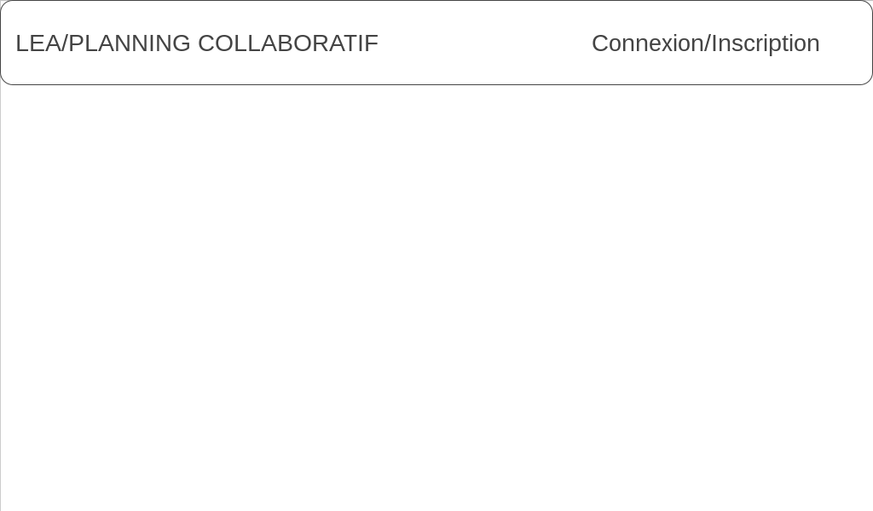
Here the connect page to the calendar. Where a user can acces to the next page after he connect :

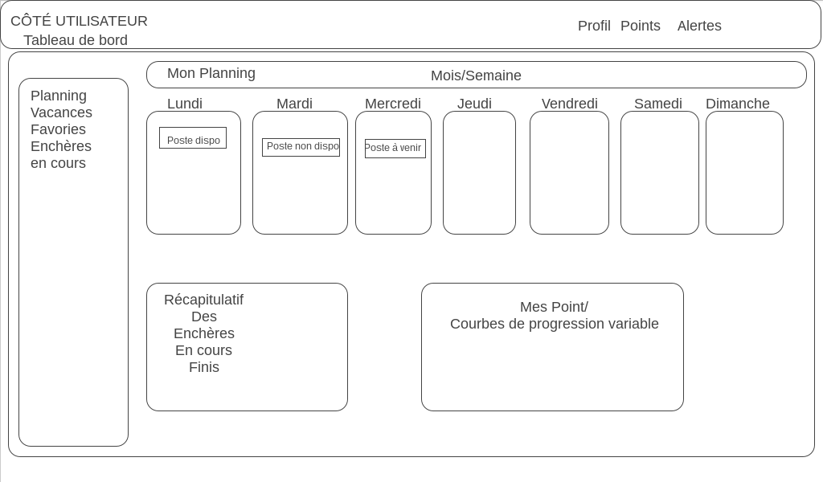
Here the personnal user page where he can see his action in progress or wins. He will can see the progress of his credits with a graph system showing his evolution on the mounth .
He can access to the top right , his bid points (usable) and a alert system who say when a bind begin or end.
He can now access to the next page :

Here the page where he can go to the differents available workplace and raise the bid with a pop-up system where he can write the price he want to put . He still can access to his profi on the to right , his bind points (usable) and a alert system who say when a bind begin or end.

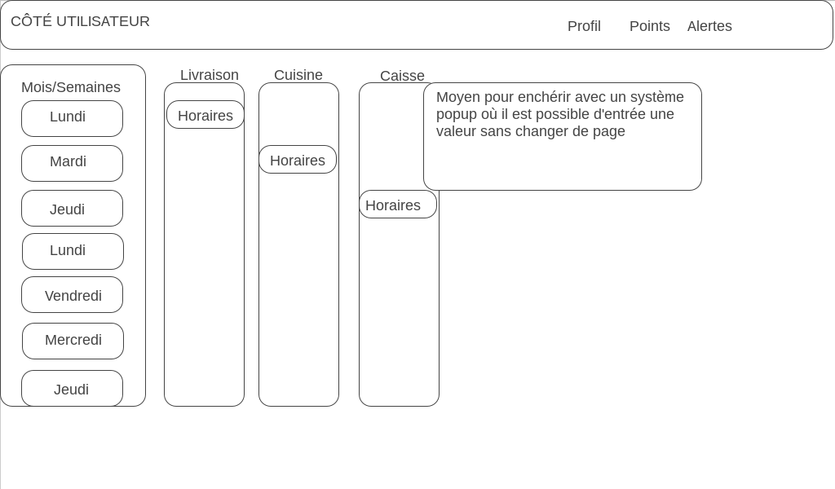

Here the admin page where the admin can add workplace for add to it.

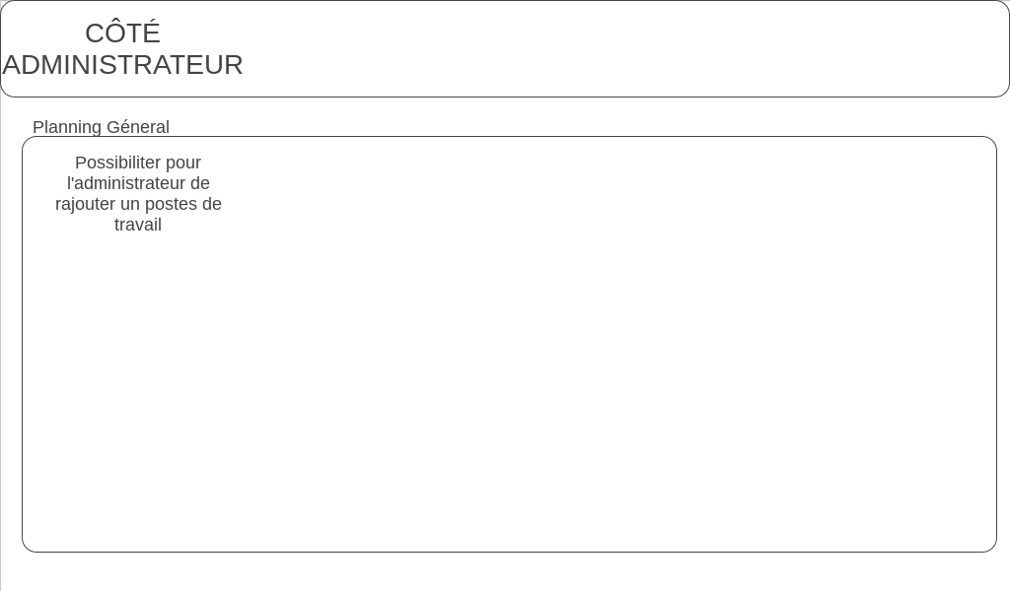

Data 1 :

The first date is limited to one workstation with a see of 3 days.
The workplace is composed of some hours who show his statue :
free(green), in progress(orange), taken(red). When we want to reserved a time slot, a chronometer start during the bid. When the chronometer as ended the time slot is gived to the user.
NB : The bid system is not operational the time slot is directly gived at the end of time .

Data 2 :

The second data bring more fonctions : A bid and credit system is bringins by person. When a bid is win we loose credits by the price of the bid and if we loose, the credits we placed are back.
We can’t place less than the last last place of the bid,a workplace can cost more than he can back.

Data 3 :

The third data bring more fonctions : A admin page and a user page.
Admin page : We can add more workplace and the users can be affect directly on a time slot .

User page : The user page show our profil with the evolution of the calendar and our credits.
This will be our personal calendar, The bids in progress, the credits represente on a graph and if we are winnig or loosing the bids .

Graph orientation and ergonomics

the visual plateform will be inspire by the model gave by the client . The client Prioritizes functionality to design.

Accessibility users + admin (login, password). Usable on all supports (phones, tablet, …).

4 – TECHNICAL ARCHITECTURE

Technical choices

Laravel, JS(jQuery), Bootstrap, MySQL, CSS.

Specifical Fonctions

As user,i can acess on a calendar updated on real time and create bids also a personal space with my curent bids.

Domain name and hosting

N/A : The society structure is not make yet, we use an fictive hosting and domain name.

5 - RESSOURCES AND DETRIMENTS

Waiting Prestation

The project is product by regional numerics school students in Saint-Gaudens and lead by Laurent Devernay.
The objective is to product a prototype to test feasibility of the project.

The internal skills will be focused around :
Méthodology, Scrum/Agile Kanban, Technologys necessary for the project.

Period

The delevery date is fixed at august 4th 2017.

Budget

None Budget, works make for free by the students, on a pedagogical framework. Also they are submit to a obligation of means but not results.

Comments

None.

